# Section: 15-4: Eleventh and Twelfth Vassa (Age 45 to 46)

This section explores the places where the Buddha resided during his eleventh and twelfth rainy seasons, as well as the Dhamma discourses he delivered during that time.

## The Eleventh Rainy Season at the Brahmin Village of Nāḷa

According to various sources, the Blessed One spent his eleventh rainy season in the Brahmin village of Nāḷa (also known as Ekanīla) in the Magadha region.

1) “The eleventh in the brāhmin village of Nāḷa.” (in Magadhā)

(*ekādasamaṁ Nāḷāyaṁ brāhmaṇagāme)* [1]

2) “The Lord of Sages, who had immeasurable intelligence, mind-captivating eyes, pure teeth, who leads people to the ageless, deathless state (of Nibbāna) by means of the deathless Dhamma, in the eleventh Rains Retreat, dwelt near the noble brāhmaṇa village named Nāla.”

*(Dhamma-amatena janataṁ ajara-amarattaṁ netto vilocana-mano-hara-suddha-danto amita-buddhi Muni-Indo, dasa-eka-Vasse, Nāla-abhidhāna-di-ja-gāma-vare vāsaṁ akā).[2]*

3) “*As has been said before, after staying at*[*Jetavana*](https://www.wisdomlib.org/definition/jetavana#theravada)*monastery in*[*Sāvatthi*](https://www.wisdomlib.org/definition/savatthi#theravada)*for as long as there were beings to be converted, the*[*Buddha*](https://www.wisdomlib.org/definition/buddha#theravada)*journeyed again and eventually reached the*[*brahmin*](https://www.wisdomlib.org/definition/brahmin#theravada)*village named*[*Ekanāḷa*](https://www.wisdomlib.org/definition/ekanala#theravada)*, in the district of Dakkhiṇāgiri, so named because it lay to the south of the hill that stood near the city of*[*Rājagaha*](https://www.wisdomlib.org/definition/rajagaha#theravada)*in*[*Magadha*](https://www.wisdomlib.org/definition/magadha#theravada)*country. There He observed the eleventh*[*vassa*](https://www.wisdomlib.org/definition/vassa#theravada)*with the brahmin village as a resort for alms*.”[3]

### Where Was Nāḷa or Ekanāla Village Located?

Some sources state that Nāḷa (or Ekanāla) was located in the kingdom of Magadha, while others suggest it was situated in the Dakkhiṇāgiri region. In the scriptures, two different places are referred to as Dakkhiṇāgiri or Dakkhiṇa Patha, as outlined below:

1. “*On one occasion the Venerable Sāriputta and the Venerable Mahāmoggallāna were wandering on tour in* ***Dakkhiṇāgir****i together with a large Saṅgha of bhikkhus*.” [4]

The sutta recounts that the female lay follower, Veḷukaṇṭakī Nandamātā [5] (also known as Uttarā Nandamātā), made a generous offering of alms to the Saṅgha, led by the Two Chief Disciples of the Buddha. According to this sutta, Nandamātā was residing in Dakkhiṇāgiri at the time. However, no records exist regarding the exact location of Dakkhiṇāgiri.

A source suggests that Dakkhiṇāgiri, also referred to as Dakṣiṇāpatha (Dakkhiṇāpatha), was situated in one of the sixteen mahājanapadas, specifically Avanti (see section 13).

*“ Avanti roughly corresponds to modern Mālwa Nimār and adjoining parts of the Central Provinces. Prof. Bhandarkar has rightly pointed out that ancient Avanti was divided into two parts; the northern part had its capital at Ujjenī and the southern part called Avanti Dakṣiṇāpatha had its capital at Māhissatī or Māhiśmatī (CL., p. 54)”[6]*. (See Map 1 below).

2. “*On one occasion the Blessed One was dwelling among the Magadhans at*

***Dakkhiṇāgiri*** *near the brahmin village of* ***Ekanāḷa****…”[7]*

According to this sutta from the Saṁyutta Nikāya, Ekanāla village was located in the Magadha Kingdom.

3. *“On one occasion the Venerable Mahākassapa was dwelling in Rājagaha in the Bamboo Grove, the Squirrel Sanctuary. Now on that occasion the Venerable Ānanda was wandering on tour in* ***Dakkhiṇāgiri*** *together with a large Saṅgha of bhikkhus…”[8]*

(Commentary says Dakkhiṇāgiri was a country in the southern region of the hills surrounding Rājagaha). [9] (See: Map3)

4. In Ambatta sutta (DN:3) The Buddha said thus:

*“ That Kanha was a mighty sage. He went to the* ***south country****, learnt the mantras of the Brahmins there, and then went to King Okkāka and asked for his daughter Maddarūpī.”[10]*

(*Here south country refers to Dakkhiṇa janapada: anglicised as the Deccan).[11]* (see: Map2).

5. In the Sutta Nipāta, we find the following verse describing a region south of Kosala, situated in Assaka and Alaka, where the renowned Brahmin Bāvari lived during the time of the Buddha:

|  |
| --- |
| *“Desiring the state of nothingness, -a brahmin master of the hymns went from the delightful city of the Kosalans- to* ***a region in the south****.* |
| *In the domain of Assaka,- in the neighborhood of Aḷaka, he lived on the bank of the Godhāvarī River -by means of gleaning and fruit.” [12]*  See Map 1, Assaka/Aṁsaka is situated below the Avanthi region. |

6. This source says:

“…*the*[*Buddha*](https://www.wisdomlib.org/definition/buddha#theravada)*journeyed again and eventually reached the*[*brahmin*](https://www.wisdomlib.org/definition/brahmin#theravada)*village named*[*Ekanāḷa*](https://www.wisdomlib.org/definition/ekanala#theravada)*, in the district of Dakkhiṇāgiri, so named because it lay to the south of the hill that stood near the city of*[*Rājagaha*](https://www.wisdomlib.org/definition/rajagaha#theravada)*in*[*Magadha*](https://www.wisdomlib.org/definition/magadha#theravada)*country. There He observed the eleventh*[*vassa*](https://www.wisdomlib.org/definition/vassa#theravada)*with the brahmin village as a resort for alms.”[13]*

7. From the following quote from the Dictionary of Pāli Proper Names by G.P. Malalasekera:

“***Dakkhiṇāgiri****v.l.****Dakkhiṇagiri.–****A district (janapada) in India (Avanti),the capital of which was*[*Ujjeni*](https://www.aimwell.org/DPPN/ujjeni.html)*, and over which*[*Asoka*](https://www.aimwell.org/DPPN/asoka.html)*ruled as Viceroy. It also contained the city of*[*Vedisā*](https://www.aimwell.org/DPPN/vedisa.html)*(Sp.i.70; Mhv.xiii.5). Dakkhiṇāgiri lay to the south of****Rājagaha****, beyond the hills that surrounded the city — hence its name. The road from Sāvatthi to Rājagaha lay through Dakkhiṇāgiri, and the Buddha traversed it in the course of his periodical tours through*[*Magadha*](https://www.aimwell.org/DPPN/magadha.html)*, residing in the Dakkhiṇāgiri-vihāra in Ekanāḷā (S.i.172; SA.ii.133; Vin.i.80).”*

Based on the information above, it appears that there were two regions referred to as Dakkhiṇāgiri (or Dakkhiṇāpatha). According to Map 1 below, if Dakkhiṇāgiri was considered a province within the Avanti region, then, as noted in the Dīgha Nikāya (see point 4 above), this location could correspond to the present-day Deccan Plateau (see Map 2).

The second Dakkhiṇāgiri, as suggested by points 2 and 3 above, may refer to Nāla village or Ekanāla in the Magadha Kingdom (see Map 3).

To simplify our task, we have concluded—based on information from the Sutta Piṭaka—that **Ekanāla village in Magadha** was where the Buddha spent his eleventh rainy season.

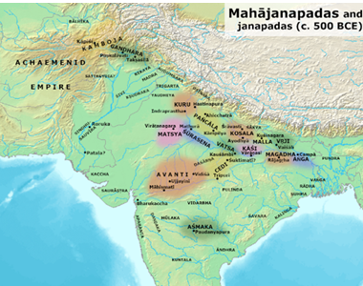

**Map 1**: Location of Avanti Region in Ancient India[14]

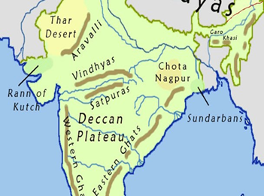

**Map 2:** Present day Geographical map of India [15]

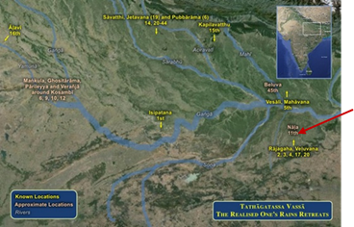

**Map3:** **The map shows the locations of Rainy-seasons.**

**Nāla is shown as the location of the 11th vassa, near Rājagaha.[16]**

## Significant Dhamma Teachings During This Period

### Teachings to the Brahmin Kasi Bhāradvāja

On one occasion, the Blessed One was residing among the Magadhans at Dakkhiṇāgiri, near the Brahmin village of Ekanāla. At that time, the Brahmin Kasi Bhāradvāja was engaged in ploughing his fields with the help of many other farmers. As the Blessed One approached the area where food was being distributed, he stood quietly to one side. Seeing him standing for alms, the Brahmin Kasi Bhāradvāja addressed him and said: [17]

*“Recluse, I plough and sow, and when I have ploughed and sown, I eat. You too, ascetic, ought to plough and sow; then, when you have ploughed and sown, you will eat.”*

The Buddha replied:   
*"I too, Brahmin, plough and sow, and when I have ploughed and sown, I eat."*

Perplexed, the Brahmin Kasi Bhāradvāja could not understand how the Buddha cultivated fields, harvested crops, and ate the food. Curious, he asked:  
*"You claim to be a man who works the plough, but I do not see your ploughing. How can this be?”*

Buddha then described his way of ploughing and reaping as follows:

*"Faith is my seed, and austerity the rain—Wisdom serves as my yoke and plough.  
Shame is the plough-pole, and the mind the yoke-tie—Mindfulness is my ploughshare and goad. With my body and speech well-guarded, and my appetite for food controlled,  
I wield truth as my weeding-hook and gentleness as my means of unyoking.*

*Energy is my beast of burden, carrying me toward freedom from bondage.  
It moves forward without stopping, to that place where sorrow does not exist.*

*Thus, this sacred ploughing is performed, yielding the fruit of the Deathless.  
And having completed this work of ploughing, one is liberated from all suffering." [18]*

Brahmin Kasi Bhāradvāja had the wisdom to recognize that he was in the presence of a Fully Enlightened Buddha—one who had attained the Deathless by cultivating the five faculties: faith, energy, mindfulness, concentration (samadhi), and wisdom. Moved by this realization, he sought refuge in the Triple Gem for life and became a devoted lay follower of the Buddha.

According to the *Sutta Nipāta* (Snp 1.4: *With Bhāradvāja the Farmer*), after establishing deep faith, Brahmin Kasi Bhāradvāja renounced worldly life and went forth under the guidance of the Blessed One. Through ardent practice, he ultimately attained arahantship.

Summary of the Discourse: **[19]**

On a spiritual journey, one must first establish faith, as it serves as the foundation for all wholesome qualities. Faith is likened to a seed planted in the soil of spirituality. Just as a seed needs rain to grow into a strong plant, virtue and restraint in bodily, verbal, and mental actions nourish and strengthen faith, allowing it to take root and flourish in the spiritual path.

Shame and fear of wrongdoing (*hiri* and *ottappa*) are compared to the twin poles of a plough, guiding one's moral discipline. Concentration (*samādhi*), generated through the unification of the mind, acts as the rope that secures the yoke. Mindfulness (*sati*) is essential, just as a farmer needs control over his plough. In the same way, the Buddha possesses deep insight and wisdom, which serve as his tools for cultivating the spiritual path.

By upholding the Truth of the Dhamma, the Buddha has uprooted the weeds of falsehood.

Through moderation in eating, he has restrained his physical cravings. His two forms of energy—both physical and mental—are likened to the powerful oxen that drive the plough of right exertion, leading him toward complete liberation. The Buddha’s Dhamma-ploughing ultimately bears the supreme fruit of Nibbāna.

##### According to Commentary:

The commentary further explains that the "fruit" in this discourse refers to arahantship, which is described as *soracca*—meaning delight in the highest good, Nibbāna (*sundare nibbāne ratattā*). The Buddha declares, *“By attaining arahantship at the foot of the Bodhi Tree, I am fully liberated and will never again come under the yoke of sufferin*g.”

Nibbāna is called *Yogakkhema*—the state of complete security, free from all bonds. The phrase *"To where, having gone, one does not sorrow"* (*yattha gantvā na socati*) is explained in the commentary (*Spk*) as referring to the unconditioned state of Nibbāna, where all the darts of suffering are removed once and for all. [20]

A Simple Explanation of This Sutta**: [21]**

Just as we cultivate crops in a field, we can also cultivate excellent qualities in the field of the mind. The Buddha refers to *Yogakkhema* (Pali: *yogakhema*) as the boundless harvest that arises from inner cultivation. *Yogakkhema* is the state of complete pacification, where the mind is freed from emotional fermentations and the root causes of suffering and grief are eradicated. In this state, one attains perfect well-being, deep peace, and ultimate awakening.

Conviction (*saddhā*), or faith, is not blind belief but arises from careful analysis of the teachings, personal experimentation, and the resulting certainty about the path. Conviction serves as the seed of spiritual cultivation—one that is not ordinary but has the power to completely transform the field of the mind. It fuels the zeal necessary for the journey, providing a clear and reasoned determination to walk the path.

Austerity is like abundant rain, nourishing the seed and fostering growth. It represents the willingness to strive and endure hardships along the way. Wisdom acts as the yoke and plough, turning over the soil of the mind to prepare it for deeper cultivation. Shame (*hiri*) functions like the plough-pole, guiding the farmer’s tool in the right direction, ensuring the field is cultivated with care and precision. The sense of shame naturally prevents one from engaging in unwholesome actions, acting as an inner safeguard. The mind serves as the strap that keeps the yoke steady on the oxen, ensuring stability on the path. Mindfulness, carefully cultivated, functions as both the ploughshare and the goad, skilfully guiding one to observe each arising moment with clarity and precision.

With restraint in body, speech, and consumption, one gains the ability to discern truthfully between what is wholesome and unwholesome. This discernment allows the weeds of unwholesome habits to be uprooted, clearing the ground for spiritual growth. Once the field of the mind is purified and made fertile, the most refined qualities can take root and flourish.

Ultimately, one’s own unwavering perseverance—both heroic and joyous—becomes the strong oxen that pull the plough forward, carrying one steadily toward true well-being, never turning back.

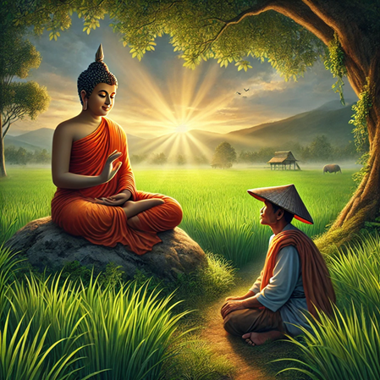

**Kasi Bhāradvāja listening to the Blessed One’s teachings [22]**

We will conclude the eleventh vassa with the story of how Kasi Bhāradvāja became a devoted lay follower of the Buddha.

# The Twelfth Rainy Season at Verañja

According to the scriptures, during the twelfth rainy season, the Buddha, accompanied by about five hundred monks, accepted an invitation from a Brahmin named Verañjā and arrived at the village (or town) of Verañja to spend the retreat there.

It is said that after listening to a discourse by the Blessed One, Brahmin Verañjā was deeply moved by the teachings. Filled with joy and conviction, he became a lay follower of the Buddha and extended an invitation for the Buddha and the Sangha to stay.

The *Vinaya Pitaka* recounts this event as follows:

“Brahmin Verañjā said:

“*Good Gotama, I go for refuge to the Buddha, the Teaching, and the Sangha of monks. Please accept me as a lay follower who’s gone for refuge for life. And please consent to spend the rainy-season residence at Verañjā together with the Sangha of monks.”*

The Buddha gave his consent through silence, which the Brahmin understood. Rising from his seat, the Brahmin bowed respectfully, circled the Buddha with his right side facing him, and then departed. [23]

The details of the Dhamma discourse that the Buddha delivered to Brahmin Verañjā are provided below under the title *Dhamma Teaching of the Period.*

**Three additional sources** also confirm that the Buddha spent his twelfth rainy season in Verañjā:

1) “*The twelfth near Verañjā”* (*dvādasamaṁ Verañjāyaṁ). [24]*

2) “*The Omniscient Sakyan Sage, in the twelfth Rains Retreat, dwelt at the foot of a Lordly Nimba tree in a monastery having delightful, fragrant, flowers and fruits, which was near the charming brāhmaṇa village of Verañjā* “ (*Sabbaññu Sakya-Muni Pucimanda-Duma-inda-mūle Verañja-cāru-di-ja-gāma-samīpa-bhūte surabhi-puppha-phala-abhirāme ārāmake, bārasamamhi Vasse, vāsaṁ akāsi). [25]*

3*) “Having thus spent the eleventh vasa at the brahmin village of Ekañāla…the Buddha set out from the village at the end of the vassa, eventually reached the city of Verañjā. He then took up residence with five-hundred monks, near the neem (nimba) tree, which was occupied by a demon, Naleru by name.” [26]*

## Where Was Verañjā Located During the Time of the Buddha?

Bhikkhu Brahmali, in his notes on the Vinaya Pitaka, mentions: [27]

*“…Regarding these names, Ven. Shravasti Dhammika from Australia shared the following insight with me in a private communication about their geographical locations:* “***Verañjā*** *is probably the huge mound at Atranji Khera, about 13 km north of Etah in Uttar Pradesh*”.

These sources say about **Atranji Khera (in Etah):**

*1) “Atranji khera is located in the Etah district of Uttar Pradesh, India. It is renowned as a prominent Buddhist site, known for its archaeological treasures. Unearthed artifacts and remnants provide valuable insights into ancient Buddhist civilization, attracting researchers and historians.”[28]*

*2) “ The great mound of ruins called*[*Atranji Khera*](https://www.jatland.com/home/Atranji_Khera)*is situated on the right or west bank of the*[*Kali Nadi*](https://www.jatland.com/home/Kali_Nadi)*four miles to the south of*[*Karsana*](https://www.jatland.com/home/Karsana_Etah)*, and eight miles to the north of*[*Etah*](https://www.jatland.com/home/Etah)*on the Grand Trunk Road.” [29]*

3) This source says: *“Verañjā (situated) to the North West of Sāvatthī on the Yamuna River. It looks like it was in the state of Pañcāla.*” [30] .

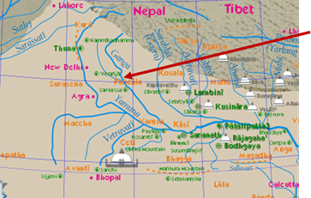

**Map showing the location of Verañjā in Ancient India[31]**

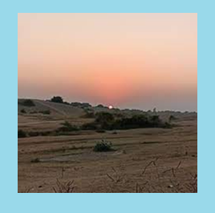

**Modern day picture of** [***Atranji Khera***](https://www.jatland.com/home/Atranji_Khera)**(ancient *Verañjā*) at Etah district. [32]**

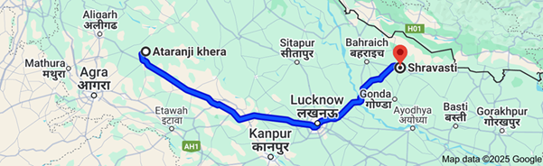

**Distance from** [***Atranji Khera***](https://www.jatland.com/home/Atranji_Khera) **to *Sāvatthī* in UP, India 440 km [33]**

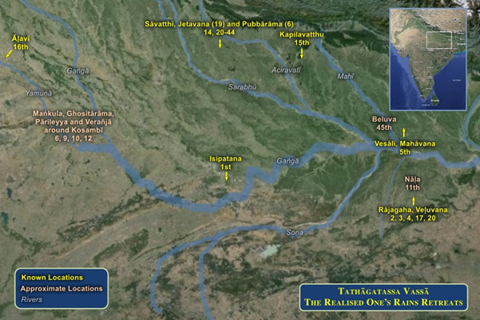

**Verañjā is located around Kosambȋ.[34]**

4) According to the following discourse from Anguttara Nikaya, it can be concluded that ancient Verañjā was located around the present-day Mathura region.

*“On one occasion the Blessed One was traveling along the highway between Madhurā and Verañjā. A number of male and female householders were also traveling along the same highway.”[35]*

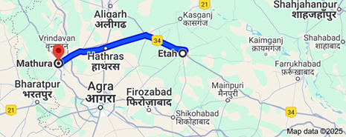

**Location of Mathura (Madhura) in UP, India[36]**

**Mathura is** a city in the state of Uttar Pradesh in northern India. It's located on the banks of the Yamuna River. Etah is the place where ancient Verañjā ([Atranji Khera](https://www.jatland.com/home/Atranji_Khera))is located. Distance from Mathura to Etah is 115 km

## Significant Events Before the Twelfth Rainy Season

### Guidance on the Importance of Harmonious Living

This discourse was delivered by the Buddha while traveling along the highway between Madhurā and Verañjā. Although the sutta does not specify the exact time of this event, it is assumed that the Buddha was on his way to Verañjā before beginning his twelfth vassa (rainy season retreat).

During his journey, a group of male and female householders was also traveling along the same highway. At one point, the Blessed One left the road and sat beneath a tree. Seeing him seated there, the householders approached, paid their respects, and sat down nearby. The Buddha then addressed them, saying: [37]

**“Householders, there are four ways in which a couple may live together. What are these four?”**

1. **The Wretched Couple:** A husband and wife who do not observe the five basic precepts, neglect generosity, refrain from offering food and gifts to ascetics and those in need, and even go so far as to insult ascetics.
2. **A Wretched Husband and a Deva-like Wife:** In this case, the husband possesses all the negative qualities mentioned above, while the wife observes the five precepts, practices generosity, offers food and gifts to ascetics and those in need, and treats ascetics with respect and honour.
3. **A Deva-like Husband and a Wretched Wife:** This is the reverse of the previous case—the husband embodies virtue and generosity, while the wife lacks these qualities.
4. **A Deva-like Couple:** Here, both husband and wife observe the five precepts, are generous in giving, support ascetics and those in need, and treat ascetics with honour and respect.

Through this teaching, the Buddha emphasized the significance of ethical conduct, generosity, and mutual respect in maintaining a harmonious and virtuous household.

Concluding the discourse, the Blessed One encouraged them to live together like devas and explained the benefits of such a harmonious life:

*"Having practiced the Dhamma here,  
Living virtuously with shared observances,  
They find delight in the deva world after death,  
Rejoicing in celestial pleasures." [38]*

Additionally, the scriptures mention that the Buddha also shared these teachings with the Sangha. [39]

### Criticizing the Buddha’s Conduct

According to the *Vinaya Pitaka*, a brahmin from Verañjā, after listening to this discourse, invited the Buddha and the Sangha to stay in Verañjā for the rainy season. This suggests that the discourse was delivered before the Buddha’s twelfth *vassa* (rainy retreat).

On one occasion, the brahmin Verañjā approached the Buddha and said:

*"Master Gotama, I have heard it said that the ascetic Gotama does not pay homage to elderly brahmins, nor does he stand up for them or offer them a seat. This is not proper, Master Gotama."*

In response, the Buddha said:

*"Brahmin, in this world of devas and humans, I see no one to whom I should pay homage, stand up for, or offer a seat. For if the Tathāgata were to show such reverence to anyone, that person’s head would split apart."*

The brahmin, unsatisfied with the Buddha’s response, pointed out eight aspects of the Blessed One’s behaviours that he deemed unacceptable to the brahmin community.

Understanding the brahmin’s concerns, the Buddha patiently addressed each point, explaining that the Tathāgata’s actions were in perfect harmony with the Dhamma and conducted in the right manner. Finally, after realizing the truth of the Buddha’s teachings, the brahmin was filled with joy and said: [40]

The brahmin, who was not convinced by the respond of the Buddha, pointed out eight factors [41] showing the Blessed Ones’ behaviour and conduct is not acceptable to the brahmin community.

The Buddha, who understood the Brahmin's mind, very kindly explained each point and explained that the Tathāgata behaved and acted in accordance with the Dhamma in a good manner. Finally, having understood the Buddha’s teachings and being glad, he said:

*"Master Gotama is truly the foremost! Master Gotama is the wisest! Excellent, Master Gotama! You have illuminated the Dhamma in many ways. From this day forward, I take refuge in Master Gotama, in the Dhamma, and in the Sangha of bhikkhus. May Master Gotama accept me as a lay follower who has taken refuge for life." [42]*

## Dhamma Teachings During the Twelfth Rainy Season

According to the scriptures, during the twelfth *vassa* (rainy season retreat), the Buddha is said to have imparted the following Dhamma teachings:

### The Marvelous Qualities of the Dhamma and the Discipline

On one occasion, the Blessed One was residing in Verañjā, at the foot of Naḷeru’s neem tree. At that time, Pahārāda, the ruler of the asuras, approached the Buddha, paid homage to him, and sat respectfully to one side.

The Buddha then asked Pahārāda whether the asuras took delight in the vast ocean. In response, Pahārāda described the remarkable and wondrous qualities of the great ocean that brought joy to the asuras. Curious, he then asked the Buddha how many extraordinary and marvelous qualities the bhikkhus recognized in the Dhamma.

In reply, the Buddha described eight astounding and remarkable qualities of the Dhamma and the discipline within his dispensation, which his disciples deeply cherished: [43]

The Buddha then described eight astounding and amazing qualities in the Dhamma and discipline of his dispensation which his disciples take delight in:

#### Eight Wonderful Qualities of the Dhamma

1. In the Dhamma and discipline, the attainment of final knowledge happens through gradual training.
2. When the Buddha prescribes a training rule, his disciples uphold it unwaveringly, even at the cost of their lives.
3. The *Saṅgha* does not associate with individuals who are immoral or of bad character; instead, such persons are expelled in accordance with the rules.
4. Upon becoming disciples, individuals renounce their social status and identify solely as followers of the Buddha.
5. Even as many *bhikkhus* attain final *Nibbāna*, *Nibbāna* itself remains neither diminished nor replenished.
6. This Dhamma and discipline possesses a single, unique taste—the taste of liberation.
7. The Dhamma and discipline contain many precious elements, including the Thirty-Seven Factors of Enlightenment.
8. This Dhamma and discipline is the dwelling place of great beings—the noble ones who have attained the four stages of awakening, from stream-entry to arahantship.

## The Dispensation of Former Buddhas

According to the *Vinaya Pitaka*, this event took place during the twelfth rainy season while the Blessed One was residing in Verañjā. [44]

On one occasion, Venerable Sāriputta approached the Buddha and asked:

*"Which Buddhas established a long-lasting spiritual dispensation, and which did not?"*

In response, the Blessed One said:

*"Sāriputta, the spiritual life established by the Buddhas Vipassī, Sikhī, and Vessabhū did not endure for long. However, the spiritual life established by the Buddhas Kakusandha, Konāgamana, and Kassapa remained for a significant period.***"**

The Buddha then elaborated further:

### Reasons for the Short Duration of a Dispensation

The spiritual dispensations of the Buddhas Vipassī, Sikhī, and Vessabhū did not endure for long because they did not make a concerted effort to provide detailed teachings to their disciples. They delivered only a few discourses—whether in prose or a combination of prose and verse—and offered limited expositions, verses, heartfelt exclamations, quotations, birth stories, extraordinary accounts, and analytical teachings.

Furthermore, they did not establish training rules or compile a monastic code of conduct. As a result, after these Buddhas and their awakened disciples had passed away, those who joined the spiritual life later lacked proper guidance, leading to its rapid decline.[45]

The Buddha illustrated this with a simile:

*"It is like scattering flowers on a wooden plank—if they are not tied together with a string, they are easily dispersed, scattered, and carried away by the wind. Why? Because they are not bound together."*

### Reasons for the Longevity of a Dispensation:

The three Buddhas—Kakusandha, Konāgamana, and Kassapa—provided their disciples with extensive teachings. They delivered numerous discourses in both prose and a mix of prose and verse, including expositions, verses, heartfelt exclamations, quotations, birth stories, extraordinary accounts, and analyses. They also established training rules and recited a monastic code.

After these Buddhas and their awakened disciples passed away, new followers joined over time, ensuring the longevity of the spiritual path. This continuity can be likened to flowers arranged on a wooden plank: when bound together by a string, they remain secure, neither scattered nor swept away by the wind. Why? Because the string holds them together.

## Establishing Training Rules in the Sangha

Not long after, Venerable Sāriputta respectfully said:  
*"Venerable Sir, now is the time to establish training rules and recite a monastic code so that this spiritual life may endure for a long time." [46]*

The Blessed One, with his all-encompassing knowledge and insight, replied:  
*"A Teacher does not establish training rules or recite a monastic code until the causes of corruption arise within the Sangha. Only when such causes emerge does the Teacher lay down training rules and recite a monastic code to counteract them."*

At that time, the Buddha also declared that all five hundred monks residing with him in Verañjā had attained noble status, ranging from stream-enterers to arahants. *[47]*

## Famine in Verañjā

On one occasion, while the Buddha and five hundred monks were spending the rainy season in Verañjā, the region was struck by famine. Crops had withered, turning to straw, and food was scarce. Obtaining alms was extremely difficult.

At that time, five hundred horse merchants from Uttarāpatha (the northern region) arrived in Verañjā, having paused their journey due to the challenging travel conditions of the rainy season. They witnessed the severe food shortage and noticed that no one was offering alms to the Sangha. Moved by the situation, the merchants decided to donate a portion of barley—a staple grain—to each monk and they brought their offerings to the monastery.

Understanding the circumstances, Venerable Ānanda took the initiative to have the barley pounded and prepared as a porridge, providing sustenance for the Buddha and the five hundred monks residing there.

Recognizing his timely efforts, the Blessed One praised Venerable Ānanda, saying:  
*"Well done, Ānanda. You are truly noble individuals who have triumphed over the hardships of famine.”[48]*

### A Request and the Buddha’s Compassion

It is also mentioned that Venerable Moggallāna sought the Buddha’s permission to obtain food from beneath the earth’s surface. However, the compassionate Buddha, who empathized with all living beings, did not approve the request, knowing that such an action would harm the creatures dwelling there.[49]

## Taking Leave After the Rainy Season

After completing the rainy season retreat, the Blessed One addressed Venerable Ānanda:  
*"Ānanda, it is the tradition of Buddhas not to wander the country without first taking leave of* *those who invited them to stay for the retreat. Let us go to the brahmin of Verañjā and take our leave."*

Then the Blessed one accompanied by large number of bhikkhus went to see Brahmin Verañjā and said to him:

*“ Brahmin, we’ve completed the rains residence according to your invitation, and now we take leave of you. We wish to depart to wander the country.”*

*“It’s true, good Gotama, that you’ve completed the rains residence according to my invitation, but I haven’t given anything. That’s not good. It’s not because I didn’t want to, but because household life is so busy. Would you and the Sangha of monks pleaseaccept a meal from me tomorrow?”[50]*

### The Buddha’s Departure from Verañjā

The Blessed One gave his consent by remaining silent. Accompanied by a large number of bhikkhus, he went to the brahmin’s house and accepted the meal offered to them. After finishing his meal, the brahmin presented the Buddha with a set of three robes and gave each monk two pieces of cloth. In return, the Buddha instructed, inspired, and uplifted him with a teaching. Then, rising from his seat, he departed.

After staying in Verañjā for as long as he wished, the Buddha set out on his journey, passing through Soreyya, Saṅkassa, and Kaṇṇakujja before reaching Payāgapatiṭṭhāna. There, he crossed the Ganges River and continued on to Benares. Remaining in Benares for as long as he pleased, he then resumed his travels toward Vesālī. Upon his arrival, he took residence in the hall with the peaked roof in the Great Wood. [51]

## The Buddha’s Journey from Verañjā to Vesālī After His Twelfth Vassa

Based on the above statement from the *Vinaya Pitaka*, we have used present-day maps to reconstruct the ancient route from Mathura to Prayag, and from there onward to Vesālī via Varanasi.

**To illustrate this journey, we have provided the following maps.[52]**

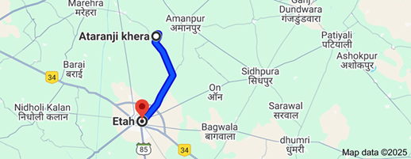

**Map: A** Atranjki Khera of UP (ancient Verañjā) to Etah, UP distance 18.5 km

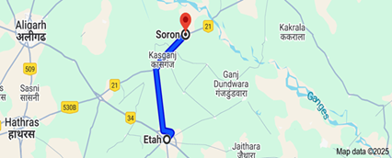

**Map B:** Etah, UP to Soron, UP (ancient Soreyya), distance 46.2 km

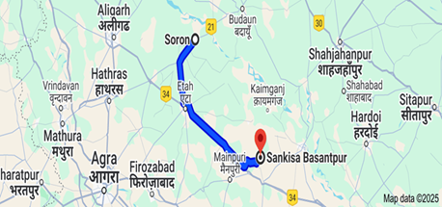

**Map C:** Soron to Sankisa Basantpur, UP (ancient Sankisa) distance 117.8 km

Sankisa is an ancient place where the Buddha landed from heaven.

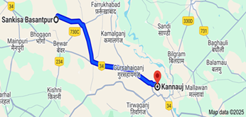

**Map D:** Sankisa Basantpur, to Kannauj, (ancient Kaṇṇakujja) distance 84.2 km

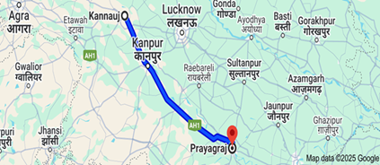

**Map: E:** Kannauj to Prayag, (ancient Payāgapatiṭṭhāna) distance 290.8 km

Prayag was the place the Buddha crossed the Ganges River.

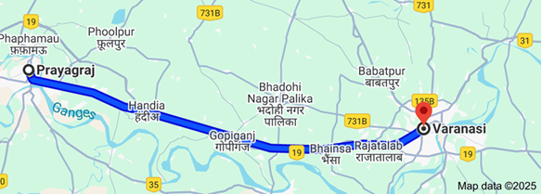

**Map: F:** Prayag, to Varanasi, UP, (ancient Benares) distance 122 km

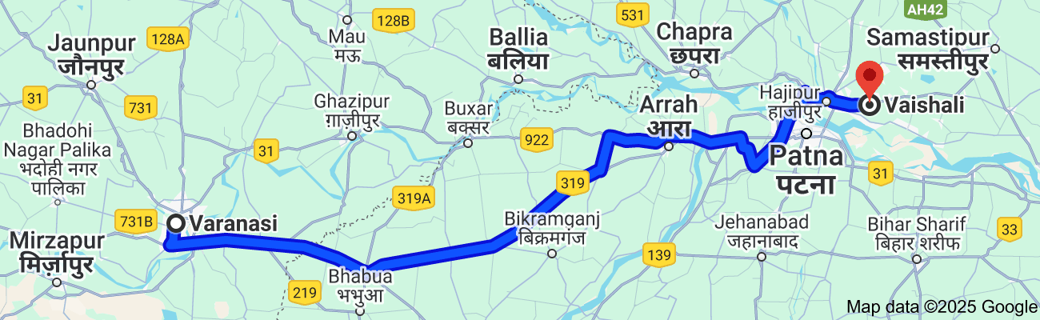

**Map: G:** Varanasi, UP to Vaishali, Bihar (ancients Vesālī) distance 302.9 km

On this long and arduous journey, the Buddha and the Sangha traversed approximately 982.4 km from ancient Verañjā to Vesālī, as estimated using present-day maps. This was not a journey of a single day; rather, in keeping with tradition, they walked about one yojana (13 -15 km) per day, embodying patience, discipline, and unwavering dedication. It is said that the Buddha maintained this steady pace throughout his walking tours, each step taken with mindfulness and great compassion.

Though historical records do not provide details of the people they encountered or the teachings shared along the way, we can deeply contemplate the profound impact of such a journey. Just the sight of the Buddha and his noble disciples—radiating serenity, wisdom, and virtue—must have uplifted countless beings. Many may have been inspired to turn toward the Dhamma, and who can measure how many took refuge in the Noble Path through these encounters?

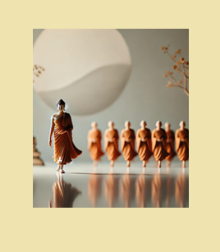

**Buddha and the Sangha travelling from ancient Verañjā to Vesālī a long journey[53]**

This pilgrimage was not merely a physical passage across the land but a journey of boundless compassion. The Buddha, out of his immeasurable kindness, walked among the people, imparting the Dhamma for the welfare of all, without distinction of caste, creed, or status. His humility was a beacon of true leadership, and his tireless efforts to bring the light of wisdom to every corner of society remind us that the path to liberation is open to all who earnestly seek it.

With that inspiring note we conclude the Buddha’s twelfth rainy season at the age of 46. In the next section, (16-1) we will explore the places where he spent his thirteenth *vassa* and the remarkable events that took place during that time.

### End Notes: Section 15-4

1. Source 1: Madhuratthavilāsinī (Buddhavaṁsatthakathā) of Bhadantâcariya Buddhadatta Mahathera: Translated by I. B. Honer, 1946.
2. Source 2: Jinacaritaṁ, The Life of the Victorious Buddha, translated by Bhikkhu Anandajoti
3. Source 3: Chapter 29: The Great Chronicles of the Buddhas by Venerable Mingun Sayadaw.
4. AN7:53 (Nandamātā sutta).
5. The Buddha declared her as the foremost of meditators among female lay followers, see: AN1: 262. * She was established in status as a non-returner, see: AN: Note: 1528.
6. Geography of Early Buddhism: Chapter 1: Majjhimadesa or Middle Country: https://ancient-buddhist-texts.net/Reference/Geography-of-Early-Buddhism/01-Middle-Country.htm
7. SN7:11 (Kasi Bhāradvāja sutta).
8. SN16:11 (The robe sutta).
9. See: SN: Note: 293.
10. DN: 3 (Ambaṭṭha Sutta).
11. See: DN: Note: 153.
12. Snp:5 (the Chapter of the Way to the Beyond- Parayanavagga, translated by Bhikkhu Bodhi)
13. Chapter 29: The Great Chronicles of the Buddhas by Venerable Mingun Sayadaw.
14. Source: Wikipedia
15. Source: <https://www.maps-of-india.com/india/india-geographical-map/>
16. Source: Maps of Ancient Buddhist India drawn and compiled by Ānandajoti Bhikkhu.
17. SN7:11.
18. Ibid.
19. For details see: SN: Note: 461 and Chapter 29: The Great Chronicles of the Buddhas by Venerable Mingun Sayadaw.
20. See: SN: Notes: 461-463.
21. Source: Way of Bodhi: https://www.wayofbodhi.org/kasibharadvaja-sutta-ploughing-mind/
22. AI generated image
23. VP: BuPj1(Translated by Bhikkhu Brahmali).
24. Source 1: Madhuratthavilāsinī (Buddhavaṁsatthakathā) of Bhadantâcariya Buddhadatta Mahathera: Translated by I. B. Honer, 1946.
25. Source 2: Jinacaritaṁ, The Life of the Victorious Buddha, translated by Bhikkhu Anandajoti.
26. Chapter 30: The Great Chronicles of the Buddhas by Venerable Mingun Sayadaw.
27. VP: BuP j1(Translated by Bhikkhu Brahmali).
28. Source: https://uptourismblog.in/buddhist-circuit/
29. Source: https://www.jatland.com/home/Atranji-Khera
30. Source: https://obo.genaud.net/backmatter/appendixes/buddhas_india/buddhas_india.htm
31. Source: admin@buddhadust.net
32. Source: https://www.justdial.com/Etah/Atranji-Khera-Achalpur/9999P5742-5742-180528223820-K8Z2_BZDET
33. Source: Google.
34. Source: Map of Ancient Buddhist India showing the locations of Buddha’s rainy seasons drawn and compiled by Ānandajoti Bhikkhu
35. AN4:53 (Living together sutta).
36. Source: Google.
37. AN4:53
38. Ibid.
39. AN:54.
40. See: VP: BuPj1 & AN 8:11 for details of the eight factors.
41. See: VP: BuPj1 & AN 8:11 for details of the eight factors.
42. AN8:11.
43. AN8:19 (*Pahārāda sutta)*
44. VP: BuPj1
45. Ibid.
46. Ibid.
47. Ibid.
48. VP: BuPj1.
49. Ibid.
50. Ibid.
51. Ibid. * In his notes, (VP: BUPj1) Bhikkhu Brahmali says: per **Ven. Shravasti Dhammika of Australia** : Verañjā is probably the huge mound at Atranji Khera, about 13 km. north of Etah in Uttar Pradesh; Soreyya is possibly Soron, directly south of Verañjā; Saṅkassa is the modern Sankisa; Kaṇṇakujja is the modern Kannauj; and Payāgapatiṭṭhāna is, as Horner correctly says, Allahabad, recently renamed Prayag, its original name. Except for the uncertain Soreyya, all these places are on a roughly west/east alignment, undoubtedly following the ancient Madhura to Payāga road.” In a subsequent email he clarified that Soron is actually north 1of Atranjki Khera or Verañjā. Following the modern road network, the total distance from Atranji Khera to Vaishali (Vesālī), according to Google maps, is in excess of 900 km.
52. Source: Google maps.
53. AI generated image.